Christmas Journey – Counting the Characters
Starting at Union Road Presbyterian Church Car park
Turn right and continue to Broad Street
Walk up Broad Street and turn down Rainey Street
Turn into Meadowlane Car park, around the back of McLaughlins and continue over to Roglyn
Continue down Queen’s Street to the Diamond
Walk around the shops on the Diamond
Continue to head to Broad Street and through Queen’s Arcade to return back to Union Road Church
The Christmas Journey begins at Union Road Church, where you can follow the trail around the town looking for characters from the Christmas Story in the shop windows.
Keep a tally of each character you see in the shop windows along the route
 | 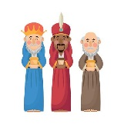 | 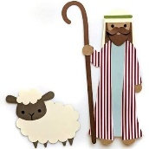 | 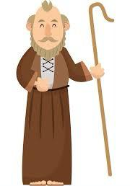
Total: | Total: | Total: | Total: | Total:

Having completed the route, and your adding up, leave this page in the post box at the manger scene at Union Road Presbyterian Church for your chance to win a prize from one of the local businesses.
NAME
CONTACT NUMBER

