The Gifts that God Gives (older children)

- What has been the best present you have ever received?

When was that and what was so special about it?

- Look up John 3 verses 16 & 17- can you write them below?

- Now, look at the verse carefully…

Every gift needs a Giver-

Who gives the Gift?

Why did He give the Gift?

What did He give?

When did He give that gift?

Who gets the Gift?

- Look up Romans 8.31-32

We read in this verse that God delivered Jesus ‘up’ for us. What do you think that means?

God the Giver
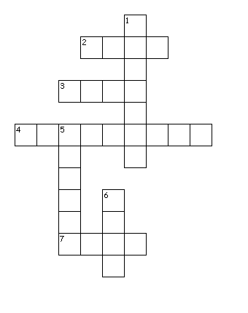
Across
2. Jesus is also known as The ________ (John 1 verse 1)
3. Which Gospel is David reading from today?
4. God sent His Son into the world at __________
7. This is the reason God sent Jesus into the world to ------ us
Down
1. This is another way of saying that God is in Three Persons
5. David also read from one of Paul's Letters today - which one?
6. This is the reason God gave His Son into the world

