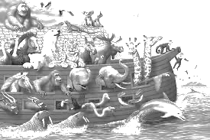

How many different animals in Noah’s ark can you count?

How many animals can you name?
Write them down below…

________________________________________________________________

Draw your favourite animal from the picture (above).

Listen out: can you hear the names of Noah’s sons- what were they?
(Genesis chapter 6 verse 10)

Write down any words you hear from David or see on the screen- ask someone at home what they mean…

Do you see the table at the front of church today?

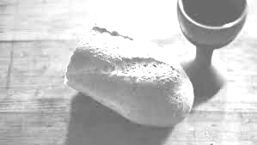

What is on it?

Do you know why?

Draw it and talk to mum or dad or granny or grandad about it.

