Noah

Can you remember any of the songs we sang this morning?
Write down the name of your favourite one:

David read from the book of Genesis- what chapter did he read from?

Look it up now to help you answer these questions…

Can you write down the name of Noah’s sons? (verse 10)

What was the ark to be made from? (verse 14)

How big was it to be? (verse 15)

How else was it to look? (v16)

Who else would be in the boat with Noah?
(verse 18)

(verse 19)

What do you think that would be like?

From what the Bible says, draw what you think the ark would look like…

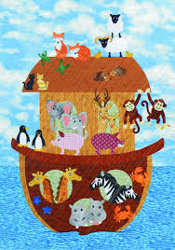 OR 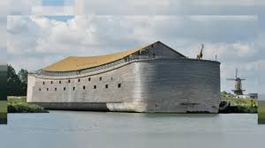

Write down what you can remember of the memory verse that Lynsey taught us today:-

What else was special in church today?

________________________________________________________________

What was different and what did you see?

Have you any questions about it- why not ask mum or dad or email/text David with mum or dad’s permission?

