Upper Primary Worksheets for Sunday 11th October

The Feast of ___________

What chapter in Leviticus are we looking at today? ______________

What are the other feasts listed in this chapter? ______________

Can you find anything that the priest had to wave before God? ______________

This Feast celebrated the end of the _______________.

- Looking into the H____________ C ___________________

R_____________________ (v16,17)

Write down anything you hear David say about this (below)

R_____________________ as a r_______________ of the r_____________________

Who was to be there? Look up Deuteronomy 16.11

R_____________________ - who were the people not to forget that day?

_______________________________________________________________Leviticus 23.22

Which Bible character gave shelter to Ruth?

B________________

Write out Ruth 2.12

- Looking _______________ to ___________________ God has promised

(v4-8) Feast of the _______________

(v15-22) Feast of ________________

What does it say that Jesus is in 1 Corinthians 15.20? ________________________________

Pentecost is recorded in Acts 2. What happened that day?

Feast of Weeks
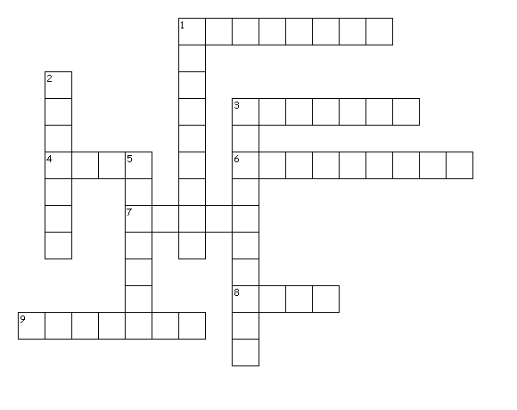
Across
1. This is the Feast where the people ate flat bread and killed a lamb
3. The Feast of weeks was also known as the Feast of ---?
4. God's people were to remember these people (Leviticus 23.22)
6. Which Bible book lists all the feasts?
7. Who was the passover lamb who died for our sins?
8. the name of the lady from Moab who married Boaz
9. The Christians spoke about the _______ of God (Acts 2)
Down
1. This is the name of the celebration 50 days after the Firstfruits
2. This is what you do when you gather in the Harvest
3. God send Him to the church at Pentecost in Acts 2
5. This is what people are to do when they see God's goodness

Write down anything you would like to ask Dave
(email to daveandjulieleach@gmail.com)

