Noah: reclaiming the rainbow
Genesis 5 & 6
(older children)

TEN to TACKLE

Look at Genesis 5 verses 1-32 in your Bibles

- How many names can you count in this list?

- What does it say in verse 1 that mankind (people) are like?

- Write down any of the names in the list that are people you have heard of before:-

- Who was the oldest man? Write his name and his age.

- How old was Adam?

- What does it say happened to every one? 4 words

and then _____ ______

- What does Noah’s name mean? Look at verse 29:-

- What is so sad about Genesis 6 verse 5?

- What did God decide to do? (Genesis 6 verse 7)

- Write out the memory verse from Hebrews 11 verse 7:

On the back of one of these sheets why not draw a birthday card for one of these very old men?

Noah
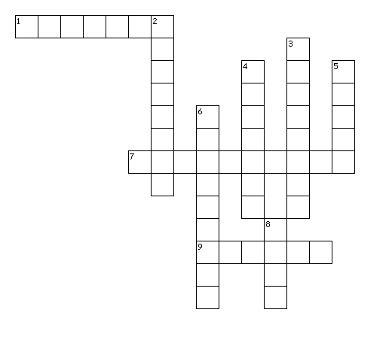
Across
1. Noah's name means this...
7. Who is the oldest man in Genesis 5?
9. Who was Noah's dad?
Down
2. God was deeply ______ (Genesis 6.6)
3. Who were the evil heroes of old in Genesis 6.4?
4. In which book of the bible do we first read about Noah?
5. Which of these men walked with God?
6. Who was Jared's dad? (Genesis 5.15)
8. What was the name of Adam's son (Genesis 5.3)?

