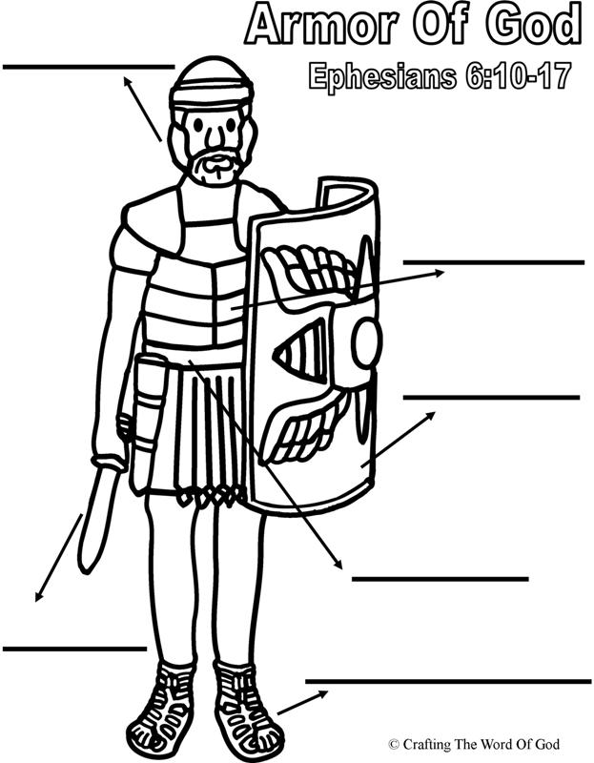

H of Salvation Breastplate of Righteousness S of the Spirit
B of truth feet fitted with the gospel of peace S of faith
Helmet of Salvation
Can you think of different types of helmets?

Mind your

- The helmet protects our

looks to attack our minds by… &

- The helmet gives us

We have hope in

Sword of the Spirit
Use the
What is the sword?
Bible verse about that:

How to use the sword? (draw a line to match the point and the bible verse)

- our Christian walk John 20:31

- our Christian walk 2nd Timothy 3:16-17

- The sword gives us Psalm 119:11

All the Bible points to
Draw a Roman Soldier wearing his armour

