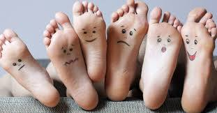
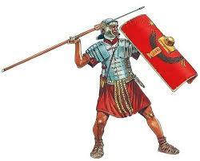
Have you ever had your feet measured?

What size are your feet?

What verse in Ephesians 6 speaks about shoes?
What kind of shoes did Roman soldiers wear?
LOOK AT THE SCREEN:
If we wear the _________ __________
they enable us to _______ or ________
with the _______ _______
Draw your favourite pair of shoes / boots / trainers.
Shoes help us ST_________ (verses 11, 13, 14)

Another way of saying the GOSPEL is G_________ N_________

We st_______ in Jesus’ _________

What does Isaiah 52 verse 7 say?
Draw a Roman shield
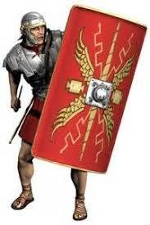
(in the spaces provided)
(eb

The shield of faith is p_______________ o______________ u________________ from everything that the enemy would th__________ at us.

FIND AND WRITE OUT PSALM 18 verses 1 & 2 in the bubble (below)

JESUS HAS _______________ ________________________

